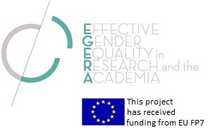

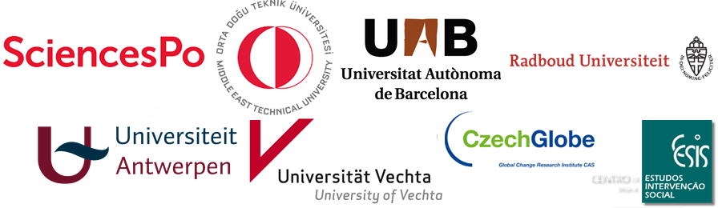

FINAL CONFERENCE
Public Programme

October 16-17-18, 2017

Monday, October 16th

2.00 – 4.00 pm: Opening

In English
Auditorium, OFCE-Sciences Po, 10, Place de Catalogne, Paris 14
2.00 – 2.30 pm: Welcome speeches
Cornelia Woll, Dean for Academic Affairs,
Xavier Timbeau, Head Director, OFCE, Sciences Po
Hélène Périvier, OFCE PRESAGE & EGERA Coordinator

2.30 – 3.15 pm: Keynote speech
Prof. Louise Morley, Sussex University

3.15 – 4.00 pm: Roundtable: Promoting Equality and a Gender Perspective in
Moderated by Prof. Mieke Verloo, Radboud University

Coffee break
4.30 – 6.00 pm: Hommage à Marie Skłodowska-Curie, à l’occasion du 150e anniversaire de sa naissance et de la publication du livre Marie Curie, une femme dans son siècle, Gründ ed.
En Français
En présence d’Hélène Langevin-Joliot
Marion Augustin, co-auteure du livre, Marie Curie, une femme dans son siècle, Gründ ed.
Nathalie Pigeard, co-auteure du livre, Marie Curie, une femme dans son siècle, Gründ ed., Historienne des sciences, CNRS

6.30 – 8.30 pm : Cocktail
Salon Rouge, Hôtel de l’Artillerie, 1, Place Saint Thomas d’Aquin, Paris 7

Tuesday, October 17th
CEVIPOF-Sciences Po, 98 Rue de l’Université, Paris 7

9.30 – 12.00am: Policy Lab “The Next Level of Sciences Po Gender Equality Policies”
Salle Annick Percheron

In English and French
Selection of innovative suggestions submitted on-line, followed by a co-design session to strengthen Sciences Po Gender Equality Policies. In partnership with the Policy Lab of Sciences Po School of Public Affairs. Participation of EGERA teams’, Advisory Committee members and other conference guests on a voluntary basis.

In parallel: Evaluation focus groups led by CESIS at the same address with steering and advisory committee members

12.30 – 2.00pm: Lunch break

2.00 – 4.30 pm: EGERA Seminar Politicization and Institutionalization of vs. Resistances to Gender Equality policies in the Academia: Where do We Stand?
Salle Lavau

In English
Pleun van Arensbergen, Monic Lansu, Inge Bleijenbergh, and Etiënne Rouwette (Radboud EGERA team): The Power of Group Model Building Interventions
Joana Gallego, Maribel Ponferrada (UAB EGERA team): Gender Perspective in Teaching in the UAB: strategies and institutionalization
Jolien Voorspoels (UA EGERA Team Antwerp): Practices of gender quota in the process leading to the composition of decision-making bodies at the University of Antwerp
Sabine Bohne (Vechta EGERA Team): Institutionalizing Gender Equality at Vechta University
Jiří Kolman, Ph.D, Apolónia Pecka Sejková (CVGZ CzechGlobe): Institutionalization of gender equality policies at CzechGlobe
METU EGERA Team Ankara: Forms of resistances encountered at different levels to the efforts of mainstreaming gender equality
Monic Lansu, Inge Bleijenbergh, Yvonne Benschop (Radboud EGERA team): Relishing resistance? Managers negotiating problem ownership in gender equality interventions
4.30 – 5.30 pm: Conclusive Roundtable
In English
Christine Musselin, Sciences Po Dean for Research
Ayse Ayata, Prof. of Political Science, Faculty of Political Science and Administration, METU Ankara
Greet Dielis, Director of the Dept. for Staff and Organization, University of Antwerp
Martina Döhrmann, Prof. of Didactics of Mathematics, Vice-President for Professors and Students, University of Vechta
Erik Koelink, Prof. of Mathematic Physics and Member of Radboud University Diversity Committee
Jiří Kolman, General Secretary, CVGZ Czech Globe
Sara Moreno Colom, Vice-Rector for Students and Professionalization, Universitat Autónoma de Barcelona

7.30pm: Diner

Wednesday, October 18th
Ecole Doctorale, 199, Boulevard Saint-Germain, Paris 7

9.00 am – 12.30pm: EGERA Steering committee: Making our GEPs sustainable

12.30 – 2.00 pm: Lunch

