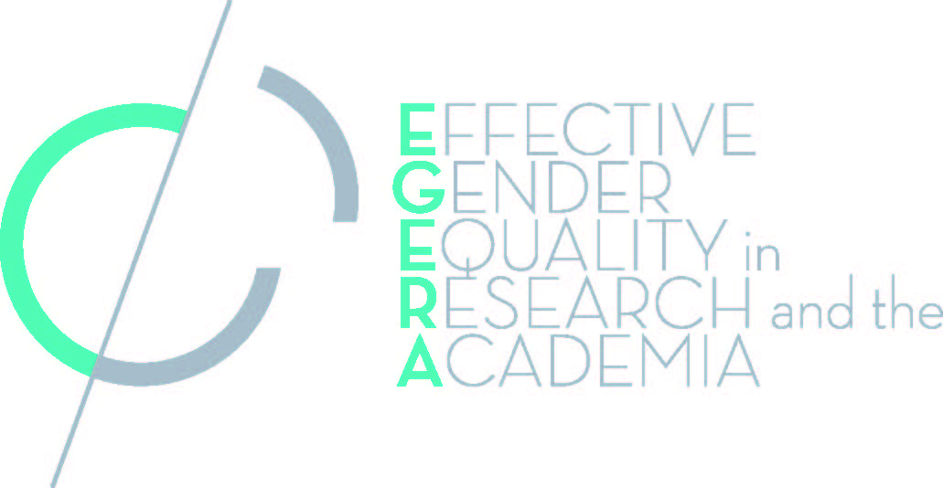 | EGERA-STAGES  co-event  2-3 March 2015 | 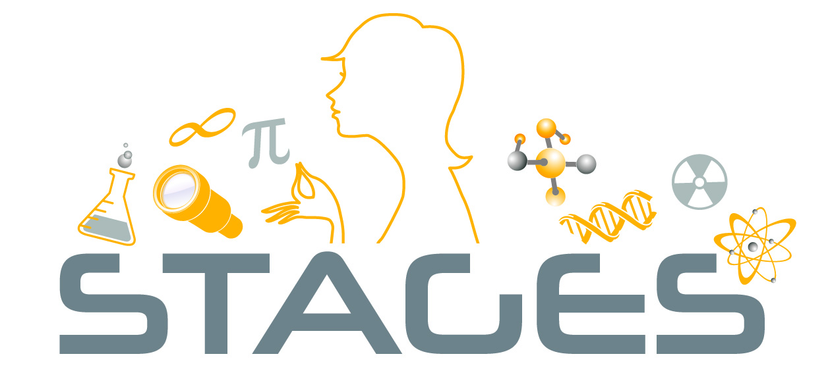

Venue: Conference Centre Soeterbeeck, Radboud University Nijmegen, Ravenstein, the Netherlands

Monday 2nd of March: Gender Equality Training

9.00 Registration and coffee
9.30 Welcome
10.00 Train-the-Trainer workshops
Parallel interactive training sessions on group facilitation. Participants get the opportunity to practice and receive feedback from experienced trainers on their group facilitation skills.
12.30 Lunch
13.30 Official opening of EGERA-STAGES co-event
13.45 Presentation on Gender Equality Training
Jojanneke van der Toorn (Leiden University)

14.30 Gender Equality Training within STAGES and EGERA
Joke Leenders (STAGES, Radboud University Nijmegen)
Monic Lansu (EGERA, Radboud University Nijmegen)
15.15 Coffee break
15.30 Exchange of Gender Equality Training experiences in subgroups
16.15 Panel discussion on Gender Equality Training
17.00 Closing
17.30 Drinks
18.30 Dinner buffet

EGERA-STAGES
co-event

2-3 March 2015

Tuesday 3rd of March: Gender in Curricula

9.00 Registration and coffee
9.30 Welcome
9.45 Gender in Curricula: best practices and resistance
Maxime Forest (scientific coordinator EGERA, Sciences Po Paris)
10.30 Coffee break
10.45 Gender in Curricula: best practices and resistance
Els Rommes (Institute for Gender Studies, Radboud University Nijmegen)
11.30 Exchange of Gender in Curricula experiences in subgroups
12.30 Lunch
13.30 Gender in Curricula: institutional embedding
Elena Del Giorgio (STAGES, State University of Milan)
14.15 Exchange of Gender in Curricula experiences in subgroups
15.00 Coffee break
15.15 Plenary discussion on Gender in Curricula
16.15 Closing

